Ex2: one against all: logistic regression

**Conclusions**-

the code demonstrates the process of training and evaluating logistic regression models for multi-class classification, including data preparation, model training, prediction, and evaluation

Prediction and Conversion: The trained models are used to make predictions on the test set. The predicted probabilities are then converted into class labels using the argmax function.

Model Evaluation: The code prints the confusion matrix, which provides insights into the classifier's performance by showing the number of true positive, true negative, false positive, and false negative predictions. Additionally, it calculates and prints the accuracy rate and F-score as evaluation metrics.

**Results-**

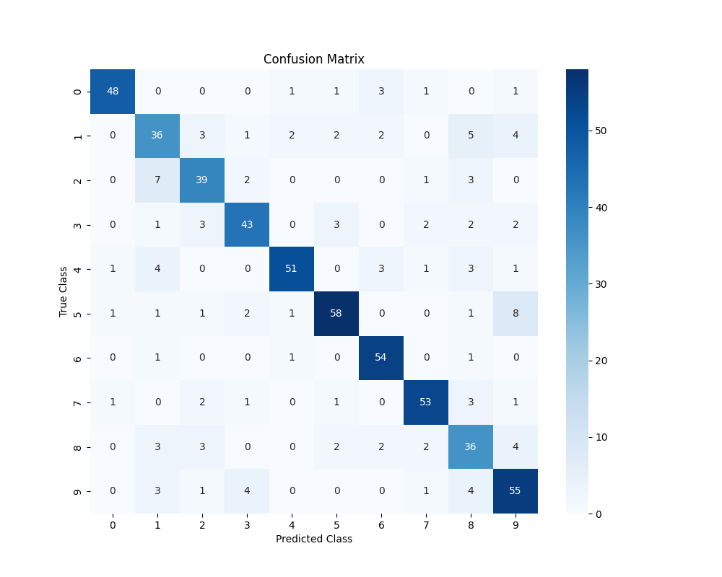

**Confusion Matrix**: The confusion matrix provides a detailed breakdown of the model's predicted classes compared to the actual classes. Each row represents instances in an actual class, and each column represents instances in a predicted class. The numbers within the matrix indicate the count of instances. The diagonal elements represent correctly classified instances, while the off-diagonal elements represent instances that were misclassified. For example, a value of 48 in the first row indicates that 48 instances belonging to Class 0 were correctly classified as Class 0, while a value of 2 in the first row and second column indicates that 2 instances belonging to Class 0 were incorrectly classified as Class 1.

**Accuracy Rate:** the accuracy rate is approximately 0.796, or 79.63%. This means that the model correctly predicted the class label for about 79.63% of the instances in the test set.

These results provide insights into the performance of the logistic regression classifier on the test set, indicating how well it can predict the correct class labels and the overall quality of the predictions.

**Observations-**

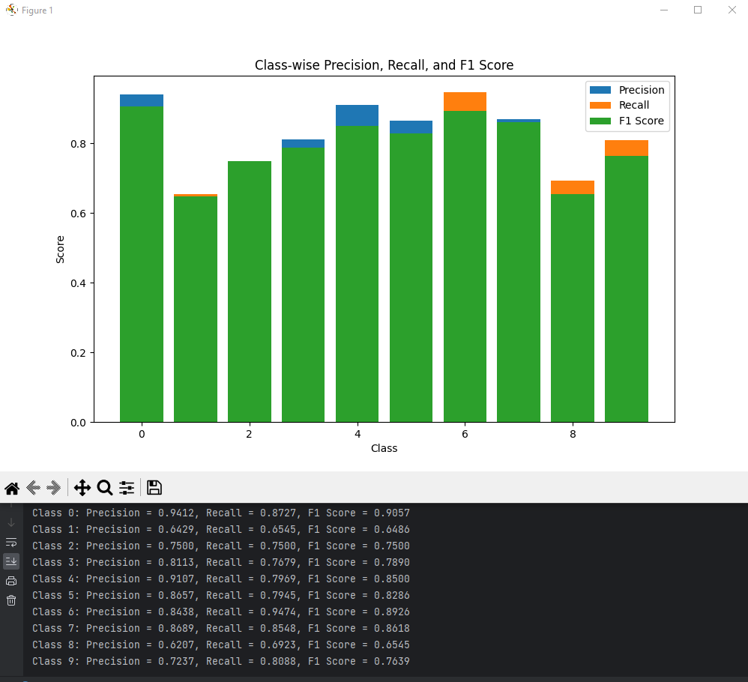

**Precision (correctly predicted positive instances)-** out of all instances predicted as positive. Higher precision indicates fewer false positives. Classes 0, 4, 5, 6, and 7 have relatively higher precision scores, suggesting that the model performs well in correctly identifying instances belonging to these classes.

**Recall (true positive rate)-** measures the proportion of correctly predicted positive instances out of all actual positive instances. Higher recall indicates fewer false negatives. Classes 0, 2, 4, 5, 6, 7, and 9 have relatively higher recall scores, indicating that the model is able to capture a larger proportion of instances belonging to these classes.

**F1 Score (balanced measure of model performance)-** It considers both precision and recall and is useful when there is an imbalance between classes. Classes 0, 2, 4, 5, 6, and 7 have relatively higher F1 scores, indicating good overall performance in terms of precision and recall.

Class 1 and Class 8: These classes have lower precision, recall, and F1 scores compared to other classes. This suggests that the model may struggle to accurately classify instances belonging to these classes, potentially indicating a class imbalance or more complex patterns that the model finds difficult to capture.